Pre-Meeting talk with Alan:

* Not clear if there will be sharing of data between departments.
* Data ownership is unclear at the moment.

WaiKong Meeting Notes:

* Alan’s idea
  + Common set of experiments for chambers downstairs
  + Needs some front-end where u enter a de-identified subject code
  + Questions:
    - What should interface look like?
    - How much data should be captured to maintain data privacy?
  + Name and subject code must exist together in an area only accessed by highly privileged individuals.
* WK: this^ assumes that data/details already exists at a lower level; the ID is the key to protect information. Once u get past this u get access to much more information where u can ID the patient. Whoever gets the lower level info mustn’t have the means or the intention to get to the source.
* WK, Switzerland, 5 clinics decided to do a national DB. Instead of 5 centres putting tog their own data, they had a central registry. The idea was that each clinic would feed the data into this registrey. To de-id you’d have an id oinly used for registry. Every time a patient is created, there is also a patient created in central registry that assig patient new id. Each centre know corresponding central id, this is hidden from other centres though.
* If a patient moves from one centre to another, the central ID gets reassigned to new source. There;s an extra table that looks at the patients’s history of ID’s. Central ID has central ids, all they needed was not the ID but the centre.
* Central ID has info about id number, as well as the centre.
* Centre has a history of patient ID’s
  + This wqay you can reconstruct where the patient has moved to/from
  + 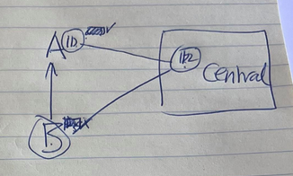
  + Patient has ID at A, when they move to B centre A gets the same ID. A shows that the patient is inactive, but they keep ID.
  + Both centres get a copy of the central ID. If patient moves back, there’s not problem.
* Data at central DB:
  + DOB, not age specifically.
  + Types of impant
    - Lhs, rhs
  + Simple information about performance
  + Age of implantation.
  + Speech perception scores.
  + No audiograms.
  + Whether they had explantations (removals of implants); for the gov, was paying for this worthwhile? Getting damaged all the time?
* WK, in terms of data security, he reckons current system is as good as he can imagine, though admits he’s not a specialist in the field.
* WK, you need to collect the patient name, it’s the backbone. There may be information branches of the patient, though they never connect.
* Should soecifc data be kept at specific centre rather than central, and if you want that info u have to approach the specific centre. Yes.
* Each participating centre much have additional field in DB for MQ anechoic ID.
* It’s up to individual centres to maintain data integrity.
* If someone were to hack Central DB, would they find out who someone is.
* WK, differential consent, in current institution, patients need to give consent when they enrol.
  + Whether we can contact GP, some obnvious things that seem redundant
  + Are we allowed to use de-id data for analysis.
    - Analysis is very broad
    - Use data for projects, studies
    - Need another field uynder Central DB where if this data is allowed for analysis.
  + If they don’t allow, they’re filtered out.
  + Each study that takes place must have a separate consent form.
  + Need consent for analysis from centre.
  + If can’t collect consent, can’t use patients for consent; if they’ve passed or if their contact details have changed, can’t collect consent.
* DB must be able to create a lot of new tables
  + Process of creating nerw tables to prevent data redundancy
  + Eg Speech tests:
    - List of existing test types
    - You have central backbone which is ID (derived from patient primary ID).
  + 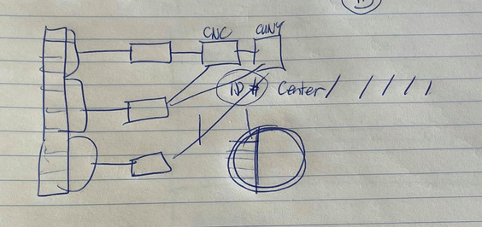
    - From each Backbone you have groups according to studies
    - For each study you have tests, these tests can overlap
    - Idea is basically that, if u do CNC and CUNY, you collect all CNCs in one large table, using foreign key to access this data, same with CUNY
    - For each kindf of test you only need one table, and one table only. ALL CNCs are in one table regardless of study, centre, etc.
    - When creating a test, decide whether it’s using an entry already collected, if using something exotic, then you create new.
* Advantage of collaboration; eg test #6 gets more data from more centres.
  + Whole idea of this shared utility.
  + Needs common front end. where somehow data is managed across different centres, that’s why Im here 😊
* MAC arena: Minimum Auditory Capability tests arena.
  + Yes/no tasks
    - Did you hear it, did you not hear it
  + Single interval multiple choice, AFCs
    - Play a sound and give people n choices, as many buttons as there are choices.
  + Open set; open set sentences and words.
  + Questionnaires: grade on a scale, hear something, what do you judge
  + 2 other things needed:
    - Something in text, ascii, described for each presentation what is the correct sounds, and then alternatives.
    - Likuyhg
* ID’s
  + CentreID
  + studyID
  + PatientID
  + AnechoicChamberID
* Master’s list that identifies patients that MUST be kept safe.
* Generate 3 digit centre ID, perhaps 4 letter study id.

ER Diagram: